Online
Safety Governance Checklist
Self-Review guidance for Governors & Proprietors to support the development of effective Online Safeguarding provision across education settings
: edition four :
September 2020

Overview and Introduction
Now in its fourth edition, this guidance has been developed for our School / College Governor and Proprietor colleagues to support the development of Online Safeguarding provision across education settings.

It draws on a variety of recommended good practice and whilst not exhaustive, seeks to prompt and highlight a number of key aspects in a summary checklist format. The guidance should therefore be viewed in the context of supporting and progressing further development when reviewing Online Safeguarding and associated local governance arrangements.

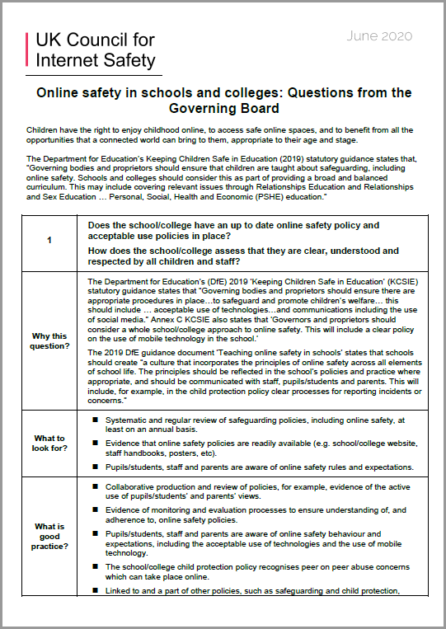
The guidance is comprised of two main sections (School-wide aspects and Governor-specific actions), providing a series of key statements to consider for each area. The guidance links with and complements the CSAP ‘Making Sense of…Keeping Children Safe in Education 2020’ guidance and the updated ‘UKCIS Questions from the Governing Board’, both available via the Pan-Lancashire CSAP Online Safeguarding website below, which contains a variety of highly-recommended tools and quality-assured resources to support the progression of Online Safety in Schools and Colleges across the region.

We hope you will continue to find this a useful and informative tool to further develop and support this important aspect of safeguarding provision.

Graham Lowe
CSAP/LSAB Online Safeguarding Advisor
Chair, Pan-Lancashire Online Safeguarding Group
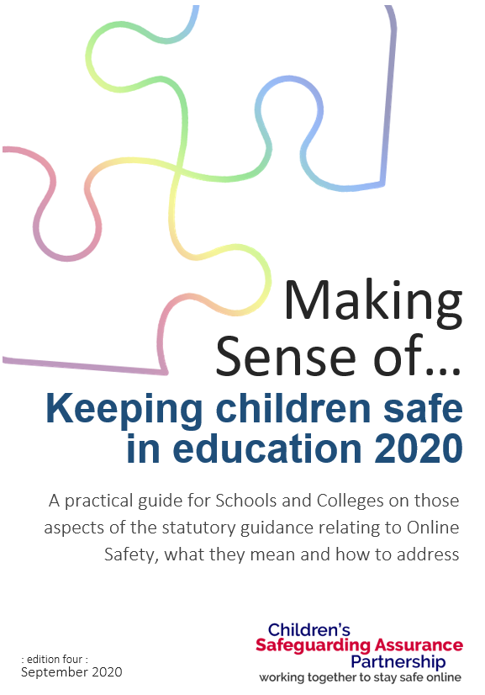
Children’s Safeguarding Assurance Partnership
September 2020
e-mail: graham.lowe2@lancashire.gov.uk
web: www.lancashiresafeguarding.org.uk
twitter: @LancsSguarding

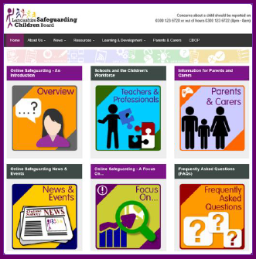
www.lancashiresafeguarding.org.uk/online-safeguarding

 | Online Safety Governor Checklist  Action
It is the responsibility of the Governor responsible for Online Safeguarding to ensure that this document is tabled at least annually at
the termly meeting of the full Governing Body or at the first meeting following any major incident.
1  revised | The School/College’s Online Safety Policy is in place and has been reviewed and updated in the last 12 months. Links to related policies are embedded (e.g. Child Protection Policy references Sexting, Peer-on-Peer abuse, GDPR requirements). Comments/Evidence: | Date:
2 | The pupil/student Acceptable Use/Behaviour Policy is in place and has been revised to accommodate developments in technology and online behaviour. Comments/Evidence: | Date:
3 | All staff (teaching/non-teaching/supply/volunteers) are familiar with the Code of Conduct (which includes the use of Social Media and staff/pupil relationships) and have signed the Staff AUP. Comments/Evidence: | Date:
4  revised | All new staff understand their responsibilities regarding Online Safety and have received Online Safety training as part of the induction process. Comments/Evidence: | Date:
5 | The School/College has effective and robust reporting mechanisms in place for Online Safety concerns. All Pupils/Students understand their Online Safety Rights & Responsibilities and clearly understand how to appropriately report concerns. Comments/Evidence: | Date:
6 | All staff (teaching and non-teaching), volunteers and supply staff clearly understand what to do if an incident occurs or is reported.  Comments/Evidence: | Date:
7  revised | The School/College regularly engages with parents/carers about Online Safety. They are aware of the School/College’s Acceptable Use/Behaviour Policy and have received/returned a copy of the internet access permission form to School/College. Comments/Evidence: | Date:
8 | The School/College regularly reviews its Online Safety provision to ensure currency and effectiveness.  Comments/Evidence: | Date:
9 | ALL users are aware of and understand the use of filtering and monitoring systems in place in the school/college (including software/hardware-based tools where appropriate). Comments/Evidence: | Date:
10 | The School/College regularly uses the SWGfL Filter-Check utility to check and evidence that the chosen filtering system is compliant with the filtering requirements highlighted within the DfE’s Keeping Children Safe in Education. Comments/Evidence: | Date:
11 | The School/College has an Online Safety Group which utilises the expertise of staff to contribute to and shape Online Safety arrangements. Comments/Evidence: | Date:
12  revised | Pupils/students are educated about Online Safety as part of a broad, balanced and progressive curriculum and their views and concerns are reflected in curriculum planning. Comments/Evidence: | Date:
13  revised | The School/College has a Designated Safeguarding Lead with an appropriate Job Description who is responsible for, and has robust knowledge of, Online Safety. Comments/Evidence: | Date:
14 | A programme of training for all staff is in place and staff receive regular updates on current and emerging risks. Staff with a specific responsibility for Online Safety (e.g. DSL) have received appropriate training in the last 12 months. Comments/Evidence: | Date:

 | Online Safety Governor Checklist  Governing Body-specific Actions
15 | An Online Safety Governor has been agreed and is part of the School/College’s Online Safety Group.  Comments/Evidence: | Date:
16 | Governors are involved in the development of and approve the Online Safety Policy, providing support and critical challenge to the school/college around Online Safety policy and practice. Comments/Evidence: | Date:
17 | All Governors understand what provision the school/college makes to keep pupils/students safe online and assess its  effectiveness. Comments/Evidence: | Date:
18 | All Governors have received recent Online Safety education and this is reflected in how the school/college develops its policy and practice. Comments/Evidence: | Date:
19 | Governors have ensured appropriate filtering and monitoring systems are in place, are involved in decisions regarding their procurement and understand what systems are used. Comments/Evidence: | Date:
20  revised | All Governors understand the statutory requirements of Keeping Children Safe in Education 2020 and the expectations of Governing Bodies and Proprietors. Comments/Evidence: | Date:

 | Online Safety Governor Checklist  Governing Body-specific Actions
Note: The previous items are provided to reflect recommended good practice and are not intended to be exhaustive. Further additional items should therefore be added to reflect local arrangements and can be included on the additional blank rows provided below.
+1 | <Additional 1>:  Comments/Evidence: | Date:
+2 | <Additional 2>:  Comments/Evidence: | Date:
+3 | <Additional 3>:  Comments/Evidence: | Date:
+4 | <Additional 4>:  Comments/Evidence: | Date:
+5 | <Additional 5>:  Comments/Evidence: | Date:

Checklist completed (Date):

Name (PRINT): Signature: Next Review Date:

